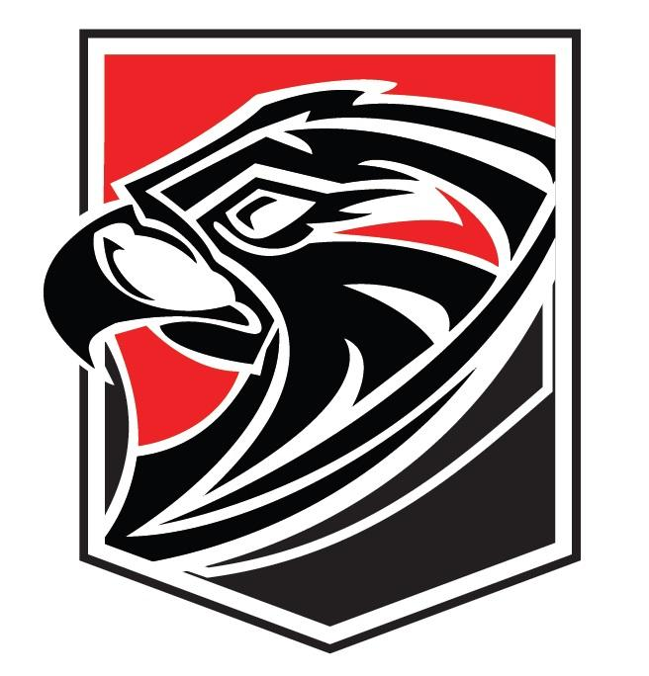
FAIRFIELD UNION RUSHVILLE MIDDLE SCHOOL 2020 7TH GRADE VOLLEYBALL
Coach: Keirstan Mirgon Superintendent: Chad Belville Principal: Tricia Haughn Assistant Principal: Dawn Rice Athletic Director: Andy Clark Trainer: Alex Craine Location: Lancaster, Ohio Nickname: FALCONS Colors: RED, BLACK, WHITE
Conference: Mid-State (Buckeye)

7th GRADE ROSTER

Jersey # 4
6 7 11 13 22 23 24 32 34
35
Player
Tristan Grubb Miranda Daley Hannah Reed Brooklyn Ash Molly Brown Nicole Davis Kate Schmelzer
Jessalyn Daubenmire Marlee Huffer
Ella Barnhart
Madalyn Lanning

