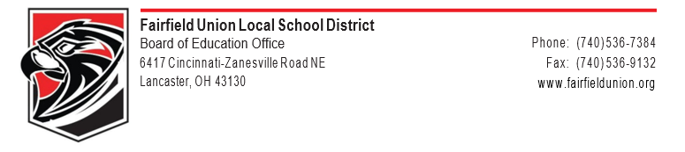

March 17, 2020

To my Fairfield Union family,

I am not sure where to begin, as the past three weeks have seemed to be a complete blur. It is still hard to grasp and understand how we have come to be in this place at this time. We are living a historical event that will be discussed and studied for generations to come. The enormity of it all is overwhelming. From this perspective, I really cannot praise and thank the staff and students of this district enough for all you have done and continue to do! All of you are simply amazing!

While it is ok to take a moment to relax from the craziness leading up to our closure, we do need to turn our focus to the future at some point. I want our district to be forward thinking, so we will be prepared for whatever may come our way. I know this practice has served us well during this crisis, and I believe it will continue to serve us well in the future. We will control our destiny and map our course going forward. I often shared the following motto with my basketball teams (and I believe it applies here as well), “We will either find a way, or make one. ~ Hannibal”

The question now becomes, “Where do we go from here?” To my students and staff, I pledge we will find a way back to some sort of normalcy in time. I am asking all students and staff to continue to work toward a return date of April 6, 2020. However, I believe in complete transparency, and this situation is no different. I have serious doubts and reservations about our school district resuming on April 6.

Our staff and students did an amazing job preparing for this closure. We were well ahead of our neighboring districts in preparations, and much of that was being proactive and realistic in our approach. It is time for us to continue this type of approach. When I am trying to guess what is to come, I look for signs that give insight into what our leaders are thinking. Here are the signs I am seeing by our leaders:

• The Ohio Department of Education has cancelled critical trainings through the end of April. • Professional sports leagues (NBA, MLB, etc…) are predicting a June start for their seasons. • The CDC is predicting a late April/early May peak of the COVID-19 virus.
• Governor DeWine has stated that schools may need to close for the remainder of the year.

These types of actions lead me to believe we will not be back in school on April 6. In fact, I find it hard to believe we would be able to resume school prior to May at the earliest. I want to stress that I HAVE NO DIRECT KNOWLEDGE WE ARE GOING TO BE OUT THIS LONG. However, I do want us to start thinking and planning for an extended closure.

To our teachers, please keep doing what you are doing. Our educational blizzard bags are doing their jobs. I am encouraged by the feedback I have received from parents and students indicating they are

working hard to complete their assignments. As we like to say, excellence is a way of life, and all Falcons are living it right now. In the coming days and weeks, we will need to start planning and thinking about what is next for when our initial wave of work sent home is completed.

To our students, especially our Seniors, you have our promise that we will not quit working for you! This time of year is one of the most special times for Seniors, and my heart absolutely breaks for you. I wish we were not in this position, but this is a great life lesson. You never know what will come your way in life, but you can control how you react to it. We know there are major events like the play, prom, and graduation that highlight four years of hard work and dedication. I assure our Seniors we will work to hold as many of these events as possible once we are cleared to resume activities in the district.

This is a trying time in our district, state and country. Have faith in each other, support your neighbors, and stand strong against adversity. We are a special breed in Falcon country, and we will find our way through this crisis. No one in this district is alone. I will close with “Anxious for Nothing” by Max Lucado:

Today, I will live today. Yesterday has passed. Tomorrow is not yet. I’m left with today.
So, today, I will live today. Relive yesterday? No. I will learn from it.
I will seek mercy for it. I will take joy in it. But I won’t live in it.
The sun has set on yesterday. The sun has yet to rise on tomorrow.
Worry about the future? To what gain? It deserves a glance, nothing more.
I can’t change tomorrow until tomorrow. Today, I will live today.
I will face today’s challenges with today’s strength. I will dance today’s waltz with today’s music.
I will celebrate today’s opportunities with today’s hope. Today.

Be well my friends,
Chad Belville, Superintendent

