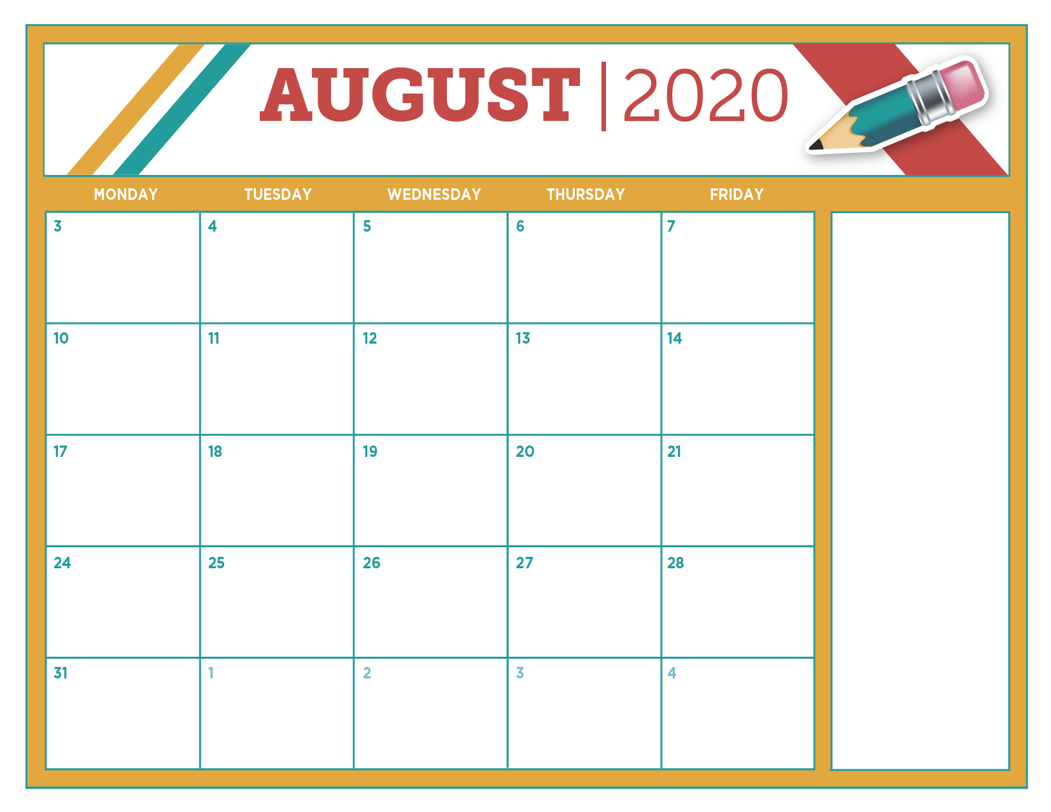
DAILY PICK-UP LUNCH MENU

ELEMENTARY STUDENT LUNCH $2.35

MIDDLE SCHOOL & HIGH SCHOOL STUDENT LUNCH $2.60

REDUCED PRICE $ .40

MEALS ARE PREPARED TO MEET THE LUNCH MEAL PATTERN GUIDELINES FOR THE NATIONAL SCHOOL LUNCH PROGRAM.
LUNCH CONSISTS OF A MEAT/MEAT ALTERNATE, VEGETABLE(S), FRUIT, GRAIN AND MILK.

HOT DOG SANDWICH SEASONED WAFFLE FRIES GREEN BEANS CINNAMON
GOLDFISH GRAHAMS FRUIT MILK

CHEESY FRENCH BREAD MARINARA SAUCE CUP GREEN BEANS TOSSED MIXED SALAD W/DRESSING FRUIT MILK

BEEF TACO IN A BAG W/CHEESE & SALSA RICE PILAF
TOSSED MIXED SALAD W/TOMATOES & DRESSING REFRIED BEANS FRUIT MILK

BACON CHEESEBURGER SANDWICH
DILL PICKLE SLICES OVEN FRENCH FRIES BABY CARROTS & BROCCOLI FLORETS SIDEKICK SMOOTH FRUIT CUP MILK

POPCORN CHICKEN BELGIAN WAFFLE MAPLE SYRUP STEAMED CORN BABY CARROTS FRUIT MILK

PHILLY BEEF STEAK W/ QUESO BLANCO CHEESE SAUCE SUB SANDWICH
STEAMED PEPPERS & ONIONS POTATO TOTS FRUIT MILK
THE STUDENT WILL RECEIVE A BREAKFAST FOR THE NEXT MORNING WHEN LUNCH IS PICKED-UP.

STUDENT BREAKFAST $1.10

FREE & REDUCED STUDENTS RECEIVE AT NO CHARGE

“MENU SUBJECT TO CHANGE”

“THIS INSTITUTION IS AN EQUAL
OPPORTUNITY PROVIDER.”

